**Behavior Policy**

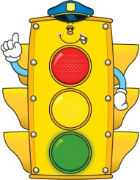

Dear Parents,

Our classroom operates on a system that promotes good behaviors and choices. As a class we have established these basic rules:

**Be a kind friend.**

**Be a good listener.**

**Follow the directions the first time.**

**Do your best work.**

We use a five-color system. The color meanings are as follows:

Pink : Student has gone above and beyond!

**Purple** : Awesome! Student has done something outstanding!

**Green** : Great! Student is having a great day!

**Yellow** : Oops/Check Yourself! Student receives a verbal warning.

**Red** : Stop! Student must fill out a *Think About It!* sheet and/or call home. *Think About It!* sheets must be signed and returned the next day.

At the end of each day, your child will reflect on his/her behavior by filling out a behavior sheet. This behavior sheet will stay in your child’s Bee Binder throughout the school year. Please review and sign it each night. Please praise them for making great choices and, if necessary, discuss how to make better ones.

If your child has stayed on green all week, they will receive an extra reward on Friday. If at any time you have questions regarding our behavior policy, please feel free to contact me!

Sincerely,

Mrs. Mazzone